Arizona Affordable Housing Snapshot
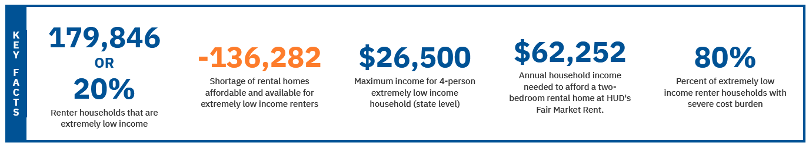
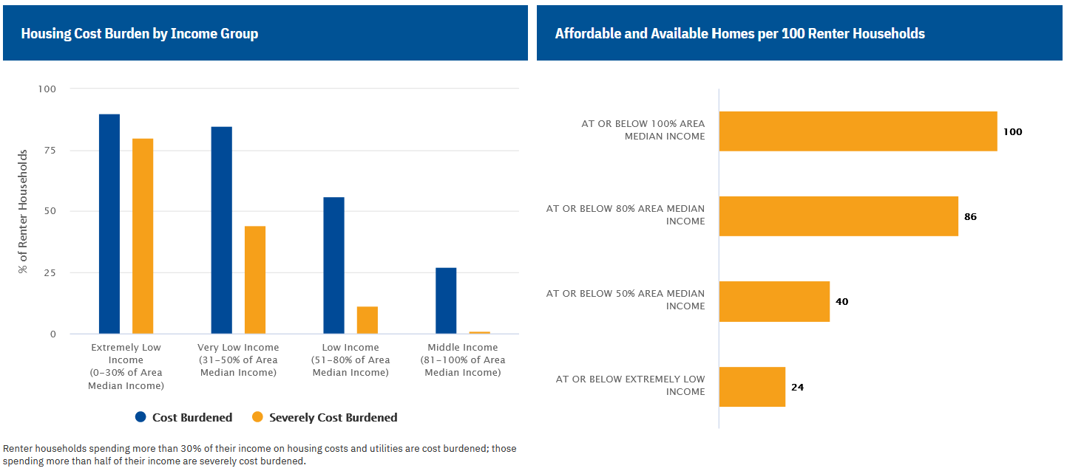
Tucson Affordable Housing Snapshot
Deficit of Affordable Housing Units for Extremely Low Income 26,085
Deficit of Affordable Housing Units at or below 50% AMI 29,703
Current Affordable Housing Supply
City of Tucson owned 1,489
Section 8 4,996
Home Ownership (need SALT / H4H) 94
LIHTC / HUD 202 4,341
Total 10,920
Units at Risk of falling out of affordability – 1,882
Affordable Housing Units in Development Pipeline - 1,192
Estimated Affordable Housing units available by 2025 – 12,018

Tucson Goal per year
3 – 9% LIHTC projects @ 75 units each – 225
2 – 4% new construction LIHTC project @ 200 ea – 400
Home Ownership 50
Other (non-LIHTC) - 80
Total - 755
Assuming a 2-3 year development cycle for new projects, all projects in operation by 2030 need to have funding commitments by 2028 (5 years).
Current Supply Stock 10,920
Under Development 1,192
Units falling out of affordability <250>
755 units / year for 5 years 3,775
2030 GOAL 15,637
With this goal, Tucson will fulfill roughly 10% of the deficit.
The average total development cost of a new affordable housing unit is between $360k - $380k per apartment when working with Tax Credits and Bonds. This will translate into a total development cost of approximately $1,397M, which will require participation from the City of Tucson of between $15M to $50M. Note that if the City of Tucson invests $2M per year in the Tucson Housing Trust fund, that alone will provide funding of $10M. The Housing Bond measure will move the City forward and make a significant contribution to developing affordable and quality housing as well as help with the gap needed to do so.
It is less expensive to build without Tax Credit and Bond funding. In these cases, the unit mix tends to be smaller, but they work well on smaller parcels.
Sources:
https://nlihc.org/gap/state/az
https://nlihc.org/housing-needs-by-state/arizona

